Week 9 – Week commencing 28/3/2022

**Week Outline**

Online meeting. Meeting mainly for bug fixing the Python Code for the NEP calculations as values are slightly off. Next, giving an overview of the project and discussing the preparations for the presentations. Otherwise, there were no significant tasks in this weeks work other than to prepare for presentation with a plan and to start thinking about writing up the project. This was the week before Easter holidays, which would give ample time for preparing for the report writing and presentation.

Several schematics of the KIDs were also provided by Dr. Tom Brien that could be used in the final report or presentation.

**Outline of Tasks**

* Create a plan/draft for the presentation
* Prepare for report write up

**Schematics of KID**

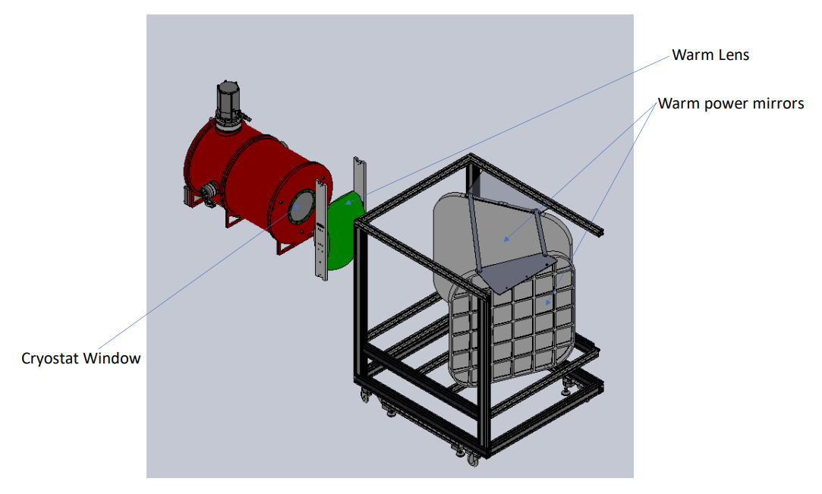

Schematic of the optics system set up for the SFAB system

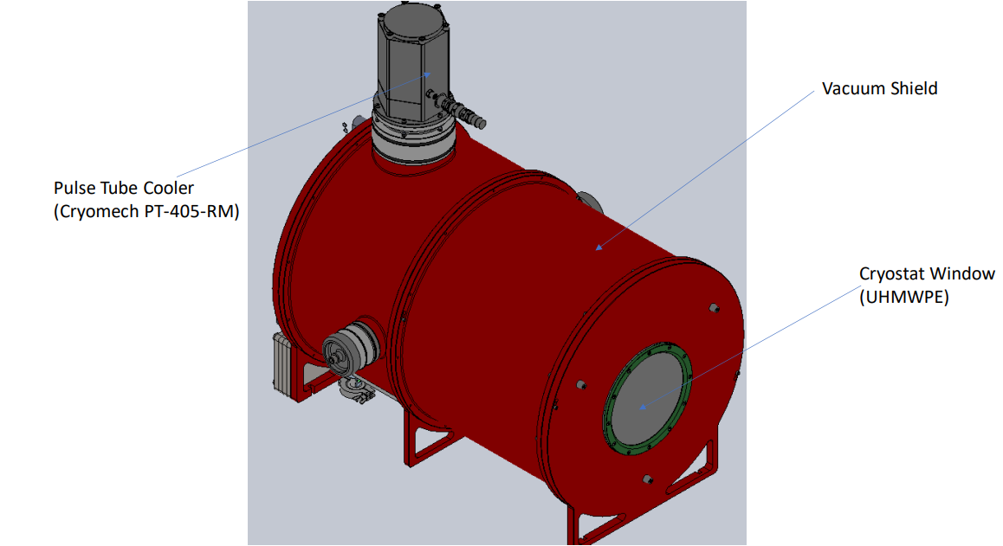

Labelled schematic of the camera

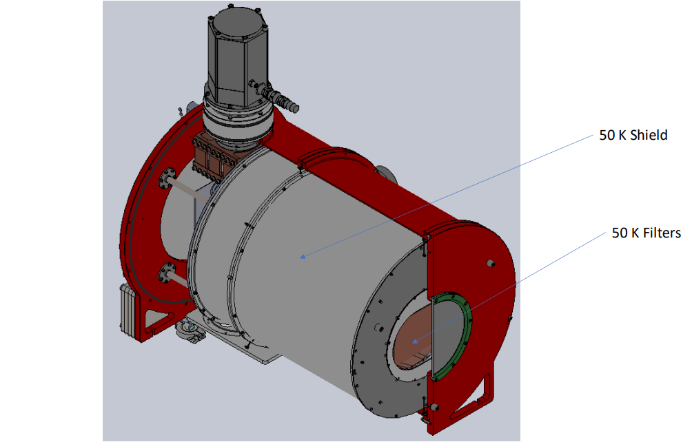Labelled schematic of inner layer of camera

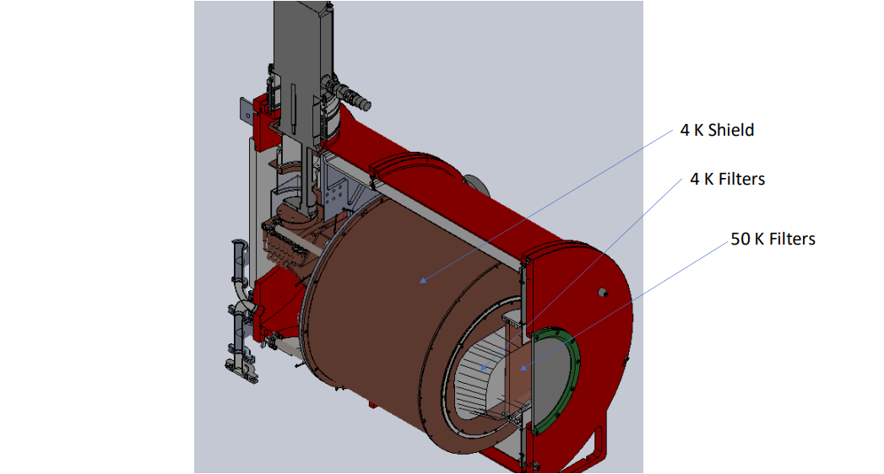

Schematic with filters and shield labelled within the camera

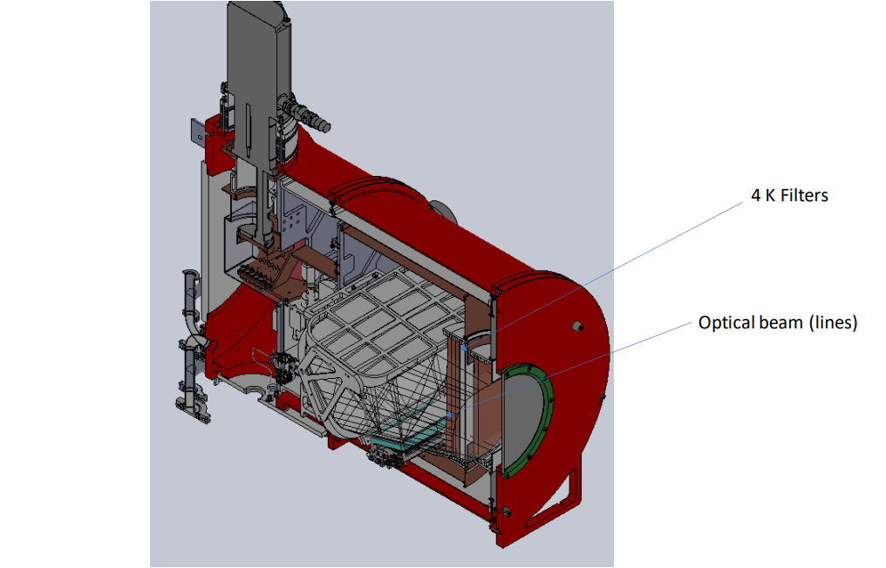

Schematic with filters and beam lines labelled within the camera

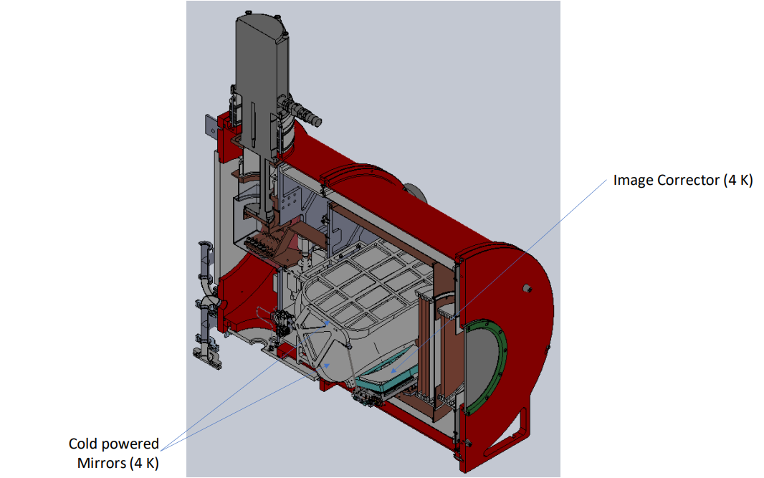

Schematic of interior of the camera

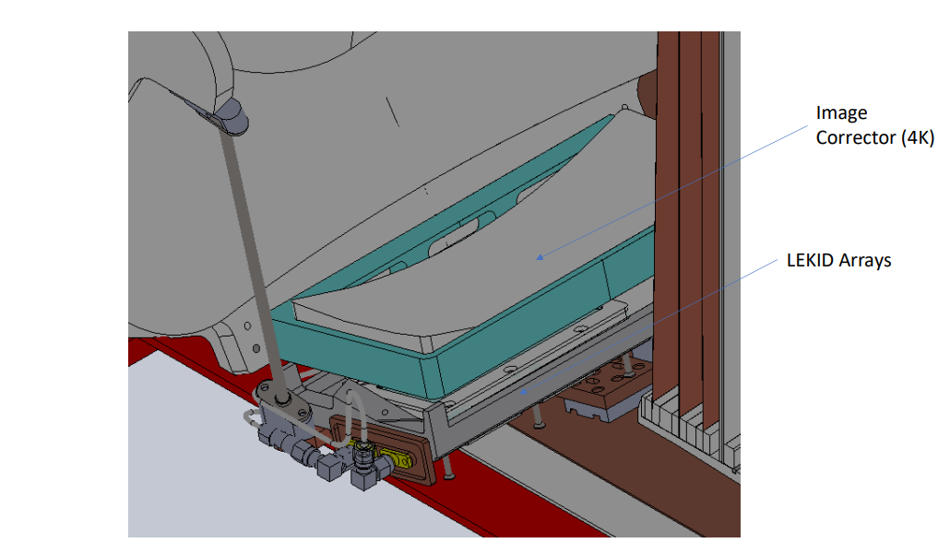

Schematic of the KID array

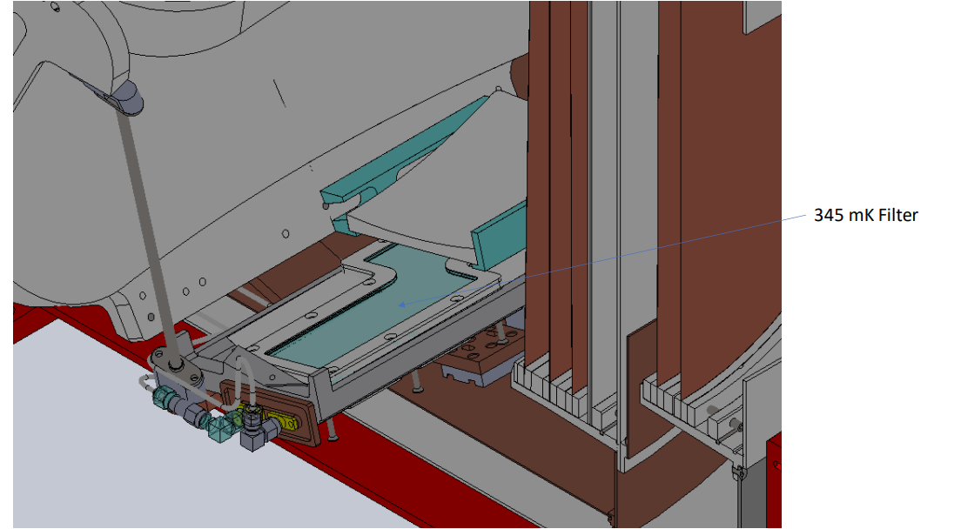

Schematic of the KID array